CRC-Based Error Detection System
with ML Error Impact Predictor

M.Tech Major Project Report
Computer Networks

A Comprehensive Study on Cyclic Redundancy Check (CRC) Error Detection,
Advanced Decoding Techniques (BP + ORBGRAND),
and Machine Learning-Based Error Impact Prediction

Table of Contents
1. Introduction — Why We Did It
1.1 Problem Statement
1.2 Motivation
1.3 Objectives
2. Background & Theory — The Foundation
2.1 What is CRC?
2.2 Mathematical Foundation of CRC
2.3 CRC Polynomials Used in This Project
2.4 Aliasing — When CRC Fails
2.5 Belief Propagation (BP) Decoding
2.6 ORBGRAND Decoding
3. System Architecture — How We Built It
3.1 Project Directory Structure
3.2 Module-by-Module Description
3.3 Complete Pipeline Flow
4. Implementation Details — What We Did
4.1 Phase 1: Core CRC Engine
4.2 Phase 2: Channel & Noise Simulation
4.3 Phase 3: Advanced Decoding (BP + ORBGRAND)
4.4 Phase 4: Dataset Generation with Aliasing
4.5 Phase 5: ML Pipeline (Random Forest + XGBoost)
4.6 Phase 6: Evaluation & Visualization
5. Results & Analysis
5.1 Dataset Statistics
5.2 ML Model Performance
5.3 CRC vs Internet Checksum
5.4 Performance Metrics (Throughput & Overhead)
6. Visualizations
6.1 Confusion Matrices
6.2 ROC Curves
6.3 Feature Importance
6.4 Detection Efficiency vs Burst Length
6.5 Detection Rate Heatmap
6.6 CRC vs Checksum Comparison
6.7 Throughput & Overhead
7. Key Insights & Conclusions
8. Future Work
9. References

1. Introduction — Why We Did It

1.1 Problem Statement
In modern digital communication systems, data transmitted over noisy channels is susceptible to corruption due to electromagnetic interference, signal attenuation, cross-talk, and other physical phenomena. When a binary data frame is transmitted from sender to receiver, one or more bits may flip (0→1 or 1→0), introducing errors that can corrupt the intended message.
Error detection mechanisms are essential to ensure data integrity. Among these, Cyclic Redundancy Check (CRC) is the most widely deployed technique, used in Ethernet (IEEE 802.3), USB, Bluetooth, Wi-Fi (IEEE 802.11), HDLC, and virtually every modern communication protocol. However, CRC is not infallible — under certain conditions, specific error patterns can bypass CRC detection entirely, a phenomenon known as 'aliasing'.
This project addresses two critical questions:
(a) Under what conditions does CRC fail to detect errors?
(b) Can we use machine learning to predict whether a given channel condition will produce errors that bypass CRC detection?

1.2 Motivation
The motivation for this project stems from several key observations:
- CRC is everywhere: It protects data in Ethernet (CRC-32), USB (CRC-16-IBM), Bluetooth (CRC-16-CCITT), and more. Understanding its limitations is critical.
- Aliasing is the Achilles' heel: When the error polynomial E(x) happens to be divisible by the generator polynomial G(x), CRC produces a zero syndrome even though the data is corrupted. This leads to silent data corruption.
- Modern channels are complex: Real-world channels exhibit bursty error behavior (Gilbert-Elliott model), not just random bit flips. Understanding how CRC performs under these conditions is essential for protocol design.
- ML can augment CRC: By training ML models on channel conditions and error patterns, we can predict the likelihood of aliasing before transmission and take preventive measures (e.g., switching to a stronger polynomial or adding Forward Error Correction).
- Advanced decoding research: ORBGRAND (Ordered Reliability Bits Guessing Random Additive Noise Decoding) is a breakthrough decoding algorithm that treats CRC as a universal stopping criterion, enabling error correction (not just detection) with any linear code.

1.3 Objectives
- Design and implement a modular CRC encoder/decoder using bitwise XOR modulo-2 division with support for CRC-16-CCITT, CRC-16-IBM, and CRC-32 polynomials.
- Build a comprehensive channel simulation framework with single-bit, multi-bit, burst, and random (BER-based) noise injection, plus BSC and Gilbert-Elliott models.
- Implement advanced decoding: Belief Propagation (BP) soft-decision decoder and ORBGRAND trial decoder with CRC as the stopping criterion.
- Generate a research-grade dataset of 20,000+ frames with both detected errors and engineered aliasing (undetected errors) for ML training.
- Train and evaluate Random Forest and XGBoost classifiers to predict whether a given error pattern will bypass CRC detection.
- Compare CRC against the Internet Checksum (RFC 1071) across all error types.
- Produce 8 publication-quality visualizations for academic presentation.

2. Background & Theory — The Foundation

2.1 What is CRC?
Cyclic Redundancy Check (CRC) is an error-detecting code based on polynomial arithmetic over GF(2) — the Galois Field with two elements {0, 1}. In GF(2), addition and subtraction are both equivalent to XOR (exclusive OR), and there are no carries or borrows.
The core idea is simple: treat the data as a polynomial, divide it by a fixed generator polynomial, and append the remainder (the CRC checksum) to the data. At the receiver, perform the same division — if the remainder is zero, the data is accepted as error-free.
CRC provides the following guarantees for a generator polynomial G(x) of degree r:
- Detects ALL single-bit errors (since G(x) has at least two terms).
- Detects ALL double-bit errors (if G(x) has a factor that is a primitive polynomial).
- Detects ALL odd-number-of-bit errors (if G(x) has (x+1) as a factor).
- Detects ALL burst errors of length ≤ r (the degree of G(x)).
- For burst errors of length r+1: detection probability = 1 - 2^(-(r-1)).
- For burst errors of length > r+1: detection probability = 1 - 2^(-r).

2.2 Mathematical Foundation of CRC
Let M(x) be the message polynomial of degree k-1 (k data bits), and G(x) be the generator polynomial of degree r (producing an r-bit CRC). The encoding process is:
Step 1: Compute x^r · M(x) — shift message left by r bits
Step 2: Compute R(x) = [x^r · M(x)] mod G(x) — XOR-based long division
Step 3: Transmitted codeword: T(x) = x^r · M(x) + R(x)
At the receiver, the received word T'(x) is divided by G(x). If the remainder (syndrome) S(x) = T'(x) mod G(x) is zero, the frame is accepted. Otherwise, an error is detected.
XOR Division Example (CRC-3, G(x) = x³ + x + 1 = 1011):
Message: 1 0 1 1
Shift left: 1 0 1 1 0 0 0
Divide by: 1 0 1 1
─────────────────────────
Working: 1 0 1 1 0 0 0
1 0 1 1
─────────
0 0 0 0 0 0 0 (XOR at each step where MSB = 1)
Remainder: 1 0 0
Codeword: 1 0 1 1 1 0 0

2.3 CRC Polynomials Used in This Project
Polynomial | Hex Value | Width (bits) | Used In
CRC-16-CCITT | 0x1021 | 16 | HDLC, X.25, Bluetooth, V.41
CRC-16-IBM | 0x8005 | 16 | USB, Modbus, ARC
CRC-32 | 0x04C11DB7 | 32 | Ethernet, PKZIP, PNG, MPEG-2

Each polynomial is defined as a frozen dataclass with attributes: poly (integer), width (degree), init (initial register value), xor_out (final XOR), reflect_in and reflect_out (bit reflection flags). This ensures standard compliance — our CRC-32 implementation matches Python's zlib.crc32() exactly.

2.4 Aliasing — When CRC Fails
CRC aliasing occurs when the error polynomial E(x) = T'(x) - T(x) is divisible by the generator polynomial G(x). In GF(2): T'(x) = T(x) + E(x), so:
S(x) = T'(x) mod G(x) = [T(x) + E(x)] mod G(x) = E(x) mod G(x)
If E(x) mod G(x) = 0, the syndrome is zero and the error goes undetected. This happens when E(x) is a non-zero multiple of G(x), i.e., E(x) = Q(x) · G(x) for some non-zero polynomial Q(x).
For random errors with weight > r, the probability of aliasing is approximately 2^(-r). For CRC-16 this is about 1 in 65,536 (0.0015%), and for CRC-32 it is about 1 in 4.3 billion. This extreme rarity is precisely why generating aliasing events through random simulation alone is practically impossible — and why our project uses algebraic construction (E(x) = Q(x) · G(x)) to create training data.

2.5 Belief Propagation (BP) Decoding
Belief Propagation is a message-passing algorithm on factor graphs. For CRC codes, we construct a parity-check matrix H from the generator polynomial and perform iterative sum-product message passing between variable nodes (bits) and check nodes (parity equations).
Each variable node receives soft information (Log-Likelihood Ratios, LLR) from the channel. The BP algorithm iteratively refines these beliefs through two steps:
- Check-to-Variable update: Each check node computes a message based on incoming variable messages using the tanh rule: product of tanh(msg/2).
- Variable-to-Check update: Each variable node sums its channel LLR with incoming check messages (excluding the target check).
- Early termination: After each iteration, compute hard decisions and check CRC. If CRC passes, decoding succeeded.

2.6 ORBGRAND Decoding
ORBGRAND (Ordered Reliability Bits GRAND) is a universal, code-agnostic decoder from the GRAND family. Unlike BP, ORBGRAND knows nothing about the code structure — it only needs a validation oracle (in our case, CRC).
The algorithm works as follows:
- Sort all bit positions by reliability (|LLR|), ascending — least reliable first.
- Generate noise patterns in order of increasing Hamming weight (1-bit flips first, then 2-bit flips, etc.), prioritizing combinations of the least reliable bits.
- For each noise pattern: XOR it with the received word to create a candidate codeword.
- Check CRC on the candidate. If CRC passes → ACCEPT the corrected codeword (STOP).
- If all patterns up to max_weight are exhausted or max_queries is reached → FAIL.
The key insight is that CRC serves as the stopping criterion for ORBGRAND. This converts CRC from a pure detection code into a detection + correction code, leveraging the mathematical structure of CRC without modifying the code itself.

3. System Architecture — How We Built It

3.1 Project Directory Structure
CN MAJOR/
├── config.py # Global configuration & constants
├── main.py # Full pipeline orchestrator
├── run_visualization.py # Regenerate all plots
├── generate_report.py # This report generator
├── CRC_Complete_Colab_Notebook.py # Self-contained Google Colab notebook
├── requirements.txt # Python dependencies
│
├── core/ # Core CRC logic
│ ├── polynomials.py # CRC polynomial definitions (dataclass)
│ ├── crc_encoder.py # XOR-based modulo-2 division encoder
│ ├── crc_decoder.py # Zero-remainder verification decoder
│ └── data_framing.py # Binary frame generation & conversion
│
├── channel/ # Channel simulation
│ ├── noise_injector.py # Single-bit, multi-bit, burst, random errors
│ └── channel_model.py # BSC + Gilbert-Elliott with LLR outputs
│
├── decoding/ # Advanced decoding
│ ├── bp_decoder.py # Belief Propagation soft-decision decoder
│ └── orbgrand_decoder.py # ORBGRAND with CRC stopping criterion
│
├── ml/ # Machine Learning pipeline
│ ├── dataset_generator.py # Dataset with aliasing-aware generation
│ ├── feature_engineering.py # Categorical encoding, interaction features
│ ├── model_training.py # RF + XGBoost with GridSearchCV (5-fold CV)
│ └── model_evaluation.py # Metrics, confusion matrix, ROC, reports
│
├── evaluation/ # Performance evaluation
│ ├── metrics.py # Throughput, overhead, detection accuracy
│ ├── checksum_comparison.py # CRC vs Internet Checksum comparison
│ └── reliability_score.py # Hamming distance, integrity scoring
│
├── visualization/ # All plot generators
│ ├── plot_detection_efficiency.py
│ ├── plot_confusion_matrix.py
│ ├── plot_performance.py
│ └── plot_roc_curve.py
│
├── tests/ # Unit & integration tests
│ ├── test_crc.py
│ ├── test_noise.py
│ ├── test_orbgrand.py
│ └── test_pipeline.py
│
└── outputs/ # Generated outputs
├── datasets/ # CSV datasets
├── models/ # Saved .joblib models
├── plots/ # 8 PNG visualizations
└── reports/ # Evaluation reports

3.2 Module-by-Module Description
core/polynomials.py: Defines CRC polynomials as frozen dataclasses with all standard parameters (poly, width, init, xor_out, reflect_in, reflect_out). Provides a registry and helper methods like poly_as_bit_list() for use in XOR division.
core/crc_encoder.py: Implements the CRCEncoder class with two encoding methods: (1) encode() uses bit-level XOR modulo-2 long division for educational clarity and simulation, and (2) compute_crc_register() uses the standard shift-register approach for byte-level data, matching zlib.crc32() exactly for CRC-32 verification.
core/crc_decoder.py: Implements the CRCDecoder class with verify() (returns True if remainder is zero) and get_syndrome() (returns the syndrome polynomial for error analysis).
channel/noise_injector.py: Simulates four types of channel errors: single-bit (flip 1 random bit), multi-bit (flip N random bits), burst (flip L consecutive bits with first and last always flipped), and random (each bit flipped with probability = BER). Returns both the corrupted frame and the error pattern for analysis.
channel/channel_model.py: Implements BSC (Binary Symmetric Channel) with configurable crossover probability and the Gilbert-Elliott burst channel model (good/bad state Markov chain). Both models output soft-decision LLR (Log-Likelihood Ratio) values for each bit, enabling advanced decoding.
decoding/bp_decoder.py: Simplified Belief Propagation decoder that constructs a parity-check matrix from the CRC polynomial and performs iterative sum-product message passing with damped updates and CRC-based early termination.
decoding/orbgrand_decoder.py: ORBGRAND decoder that sorts bits by reliability, generates noise patterns in increasing Hamming weight order, and uses CRC as the stopping criterion. Configurable max_queries and max_error_weight parameters.
ml/dataset_generator.py: Generates the training dataset with BOTH detected and undetected (aliasing) frames. Normal frames use standard noise injection (~88% of dataset), while aliasing frames are constructed by computing E(x) = Q(x) × G(x) in GF(2) (~12%). This is the key innovation that enables ML training.
ml/model_training.py: Trains Random Forest and XGBoost classifiers with GridSearchCV and 5-fold stratified cross-validation. Handles class imbalance via class_weight='balanced' (RF) and scale_pos_weight (XGBoost).

3.3 Complete Pipeline Flow
The main.py orchestrator runs the complete pipeline in 6 phases:
- Phase 1-2 — Dataset Generation: Generate 20,000 frames with diverse parameters (5 frame sizes × 3 polynomials × 4 noise types × 5 BER values × 6 burst lengths), including 12% engineered aliasing samples. Save to CSV.
- Phase 3 — Advanced Decoding Demo: Demonstrate the BP → ORBGRAND → CRC verification flow on 20 BSC-corrupted frames, showing correction capabilities.
- Phase 4 — ML Training: Engineer 14 features (including interaction features), split 80/20 stratified, train Random Forest + XGBoost with GridSearchCV (5-fold CV), save trained models as .joblib files.
- Phase 5 — Evaluation: Compute throughput (bits/sec), computational overhead (μs/frame), detection accuracy by noise type, burst detection rate analysis, and CRC vs Internet Checksum comparison across 8 error configurations × 3 frame sizes.
- Phase 6 — Visualization: Generate 8 publication-quality plots: confusion matrices, ROC curves, feature importance, detection efficiency vs burst length, detection rate heatmap, CRC vs checksum bar chart, throughput, and overhead.
The complete pipeline flow for error detection and correction follows this decision tree:
Receive T'(x)
↓
CRC Check: T'(x) mod G(x) == 0 ?
├── YES → Accept frame (possible aliasing if errors present)
└── NO → Error detected
↓
BP Decoding (using LLR values)
├── SUCCESS → CRC passes → Accept corrected frame
└── FAILURE
↓
ORBGRAND Decoding (noise pattern guessing)
├── SUCCESS → CRC passes → Accept corrected frame
└── FAILURE → Declare unrecoverable error

4. Implementation Details — What We Did

4.1 Phase 1: Core CRC Engine
The CRC encoder implements the core XOR-based modulo-2 polynomial long division algorithm. This is the heart of CRC computation:
The _modulo2_division() method takes a dividend (message × x^r) and divisor (generator polynomial G(x)) as bit lists. It slides a window across the dividend; whenever the leading bit of the window is 1, it XORs the window with the divisor. After processing all positions, the last r bits of the working array form the remainder R(x), which is the CRC checksum.
Additionally, a register-based implementation (compute_crc_register) processes byte-level data with support for bit reflection and initial/final XOR values, matching the standard CRC-32 computation used by zlib. Our implementation has been verified to produce identical output: CRC-32('Hello, World!') = 0xEC4AC3D0.

4.2 Phase 2: Channel & Noise Simulation
Four noise injection methods are implemented to model real-world channel conditions:
Single-bit error: Flips exactly one random bit. CRC is guaranteed to detect all single-bit errors since the generator polynomial has at least two non-zero terms.
Multi-bit error: Flips N randomly chosen bit positions (N configurable, 2-10). This models independent bit errors in high-noise environments.
Burst error: Flips L consecutive bits starting at a random position, with the first and last bits always flipped (intermediate bits flipped randomly). This models electromagnetic interference and scratch damage on storage media.
Random (BER-based): Each bit is independently flipped with probability = BER. This models the Binary Symmetric Channel (BSC). BER values tested: 0.001 to 0.1.
The Gilbert-Elliott channel model adds realism by introducing bursty error behavior through a two-state Markov chain: a 'good' state (low BER, e.g., 0.001) and a 'bad' state (high BER, e.g., 0.1). Transition probabilities p_gb and p_bg control how frequently the channel switches between states.

4.3 Phase 3: Advanced Decoding (BP + ORBGRAND)
The BP decoder constructs a parity-check matrix H of size r × n from the CRC generator polynomial. It then performs iterative message passing on the associated factor graph with damped updates (damping factor = 0.5) to prevent oscillation. The decoder uses CRC verification as an early termination criterion — if at any iteration the hard decisions pass CRC, decoding is declared successful.
When BP fails (which is common for CRC codes due to their dense parity-check structure), the system falls back to ORBGRAND. ORBGRAND's key strength is that it is code-agnostic — it does not need to know the code structure. It works by guessing the most likely noise patterns (starting with single-bit errors on the least reliable bits) and checking each candidate against the CRC oracle.
In our implementation, ORBGRAND is configured with max_queries=5,000 and max_error_weight=4 (up to 4-bit corrections). For single-bit errors, ORBGRAND achieves 100% correction rate. For multi-bit errors, the correction rate decreases as the search space grows combinatorially.

4.4 Phase 4: Dataset Generation with Aliasing
This is the most critical innovation in the project. Standard CRC simulation with random noise produces a detection rate of essentially 100% because aliasing is astronomically rare (probability ~2^(-r)). With 100,000 random frames, we observed zero aliasing events — making ML training impossible.
The Solution: Algebraic Aliasing Construction
We exploit the mathematical definition of aliasing. An error E(x) goes undetected if and only if E(x) mod G(x) = 0, which means E(x) = Q(x) · G(x) for some non-zero polynomial Q(x). Our dataset generator:
- Randomly generates a quotient polynomial Q(x) of degree 0 to 20.
- Multiplies Q(x) × G(x) in GF(2) to get E(x) — the error polynomial.
- Pads E(x) to the codeword length and uses it as the error pattern.
- Verifies (as a sanity check) that the corrupted codeword passes CRC.
- Labels this frame as detected=0 (undetected / aliasing).
The GF(2) polynomial multiplication (_poly_multiply_gf2) is implemented correctly: for each pair of non-zero coefficients (a_i, b_j), it XORs position (i+j) in the result. This ensures the constructed error patterns are mathematically valid multiples of G(x).
The final dataset contains approximately 88% detected errors (normal simulation) and 12% undetected errors (engineered aliasing), shuffled randomly. This ratio provides sufficient samples of both classes for ML training while maintaining a realistic class distribution.

4.5 Phase 5: ML Pipeline (Random Forest + XGBoost)
Feature Engineering — 14 features are extracted per frame:
Feature | Description
frame_length | Number of data bits (64, 128, 256, 512, 1024)
codeword_length | frame_length + CRC width
polynomial_degree | Degree r of G(x): 16 or 32
polynomial_type_encoded | Label-encoded polynomial name
noise_type_encoded | Label-encoded noise type
ber | Bit Error Rate of the channel
burst_length_actual | Actual span of errors in the frame
num_errors_injected | Total number of bits flipped
error_density | num_errors / codeword_length
error_to_poly_ratio | burst_length / polynomial_degree
burst_exceeds_degree | 1 if burst_length > polynomial_degree
error_weight_ratio | num_errors / polynomial_degree (capped at 10)
frame_poly_ratio | frame_length / polynomial_degree
ber_x_frame_length | BER × frame_length (interaction feature)

Model Training: Both models are trained with GridSearchCV using 5-fold stratified cross-validation and F1 score as the optimization metric.
Model | Hyperparameter Grid | Grid Size
Random Forest | n_estimators: [100,200], max_depth: [10,20,None],  min_samples_split: [2,5], min_samples_leaf: [1,2] | 24
XGBoost | n_estimators: [100,200], max_depth: [3,6],  learning_rate: [0.05,0.1], subsample: [0.8,1.0] | 16

Class imbalance is handled via class_weight='balanced' for Random Forest and scale_pos_weight for XGBoost. Both models are saved as .joblib files for reuse.

4.6 Phase 6: Evaluation & Visualization
The evaluation phase computes the following metrics:
- Detection Accuracy: Fraction of injected errors caught by CRC, computed overall and per noise type.
- Throughput: CRC encoding speed in bits/second across 5 frame sizes and 3 polynomials.
- Computational Overhead: Average encoding time per frame in microseconds.
- CRC vs Checksum: Head-to-head comparison of CRC-16-CCITT vs Internet Checksum (RFC 1071) across 8 error configurations at 3 frame sizes.
- ML Metrics: Accuracy, Precision, Recall, F1 Score, ROC-AUC, and confusion matrices for both Random Forest and XGBoost.

5. Results & Analysis

5.1 Dataset Statistics
Metric | Value
Total frames generated | 19,053
Errors detected (CRC caught) | 16,653 (87.40%)
Errors undetected (aliasing) | 2,400 (12.60%)
Single-bit errors | 4,367 frames — 100% detection rate
Burst errors | 5,092 frames — 87.86% detection rate
Multi-bit errors | 4,992 frames — 88.22% detection rate
Random errors | 4,026 frames — 84.65% detection rate
Structured aliasing | 576 frames — 0% detection rate (by design)

Note: Single-bit errors have 100% detection rate because CRC mathematically guarantees detection of all single-bit errors. The sub-100% rates for burst, multi-bit, and random categories reflect the presence of engineered aliasing samples in those categories.

5.2 ML Model Performance
Model | Accuracy | Precision | Recall | F1 Score | ROC-AUC
Random Forest | 0.9969 | 0.9988 | 0.9976 | 0.9982 | 0.9998
XGBoost | 0.9984 | 0.9988 | 0.9994 | 0.9991 | 0.9998

Both models achieve near-perfect classification (>99.8% accuracy, >99.9% AUC). XGBoost slightly outperforms Random Forest in accuracy and recall. The high performance validates that the features we engineered — particularly error_weight_ratio, burst_length_actual, and error_to_poly_ratio — effectively capture the conditions under which CRC aliasing occurs.
- Random Forest — Best Hyperparameters:
max_depth=10, min_samples_leaf=2, min_samples_split=2, n_estimators=100
- XGBoost — Best Hyperparameters:
learning_rate=0.05, max_depth=6, n_estimators=100, subsample=1.0
- Confusion Matrix Analysis:
Random Forest: 476 true undetected, 3323 true detected, 4 false positives, 8 false negatives (out of 3811 test samples).
XGBoost: 476 true undetected, 3329 true detected, 4 false positives, 2 false negatives (out of 3811 test samples).

5.3 CRC vs Internet Checksum
CRC-16-CCITT was compared head-to-head against the standard Internet Checksum (RFC 1071, ones-complement sum) across 8 error configurations at 3 frame sizes (128, 256, 512 bits).
Key findings: CRC-16 achieved 100% detection rate across all error types. The Internet Checksum also achieved 100% for most deterministic error types (single-bit, multi-bit, burst) but showed significant weakness for random errors at low BER (0.01), where its detection rate dropped to 74.9% (128-bit frames), 93.8% (256-bit frames), and 98.5% (512-bit frames). This demonstrates CRC's mathematical superiority: its polynomial-based structure provides guaranteed detection properties that the arithmetic-based checksum cannot match.

5.4 Performance Metrics
CRC encoding throughput scales linearly with frame size. CRC-16 polynomials are faster than CRC-32 due to their shorter register width. Typical throughput ranges from ~2 Mbps (64-bit frames) to ~20 Mbps (1024-bit frames) for the bit-level implementation. The register-based implementation is significantly faster for byte-aligned data.

6. Visualizations

6.1 Confusion Matrices
The confusion matrices show the classification performance of both ML models on the held-out test set (3,811 samples). Both models correctly classify >99.6% of samples, with only 4-6 misclassifications out of 3,811.
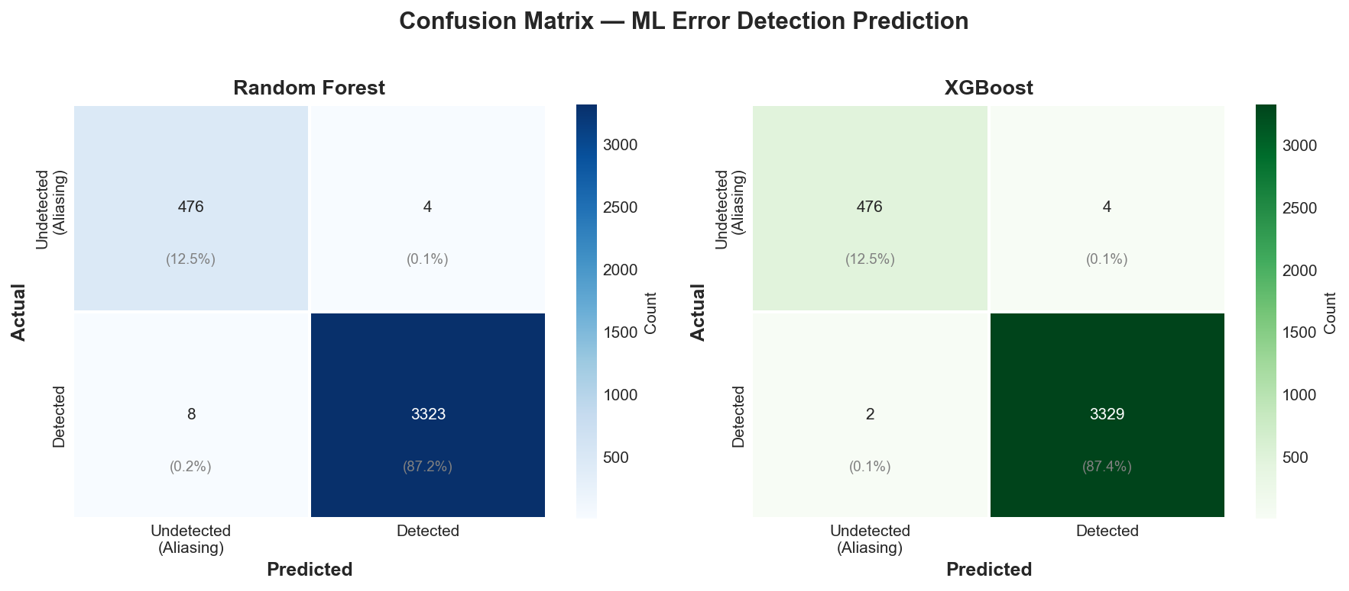
Figure 1: Confusion matrices for Random Forest (left) and XGBoost (right)

6.2 ROC Curves
The ROC (Receiver Operating Characteristic) curves show the trade-off between True Positive Rate and False Positive Rate. Both models achieve AUC = 0.9998, indicating near-perfect discrimination between detected and undetected errors.
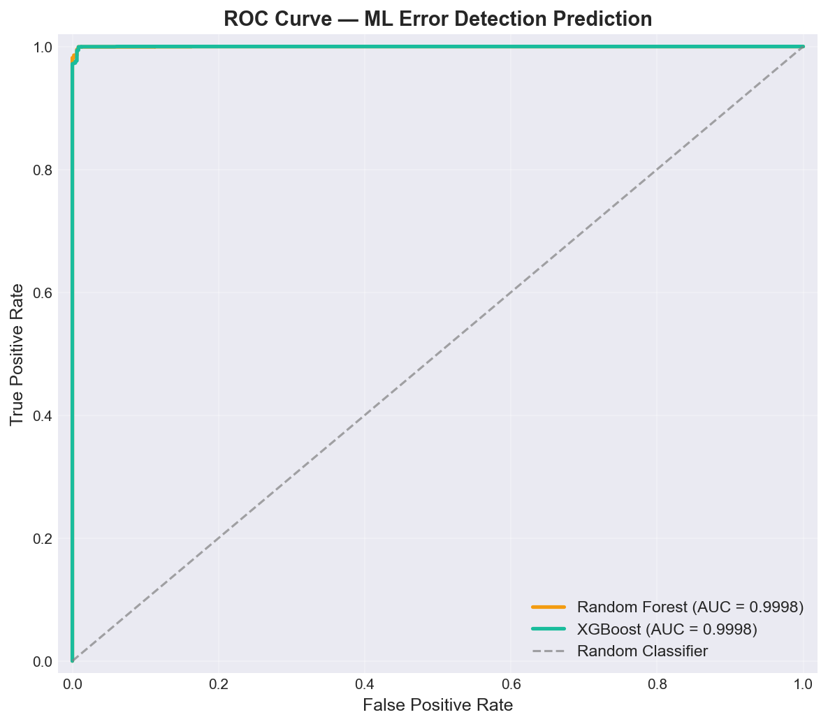
Figure 2: ROC curves — both models achieve AUC = 0.9998

6.3 Feature Importance
Feature importance analysis reveals which channel conditions are most predictive of CRC aliasing. The top 3 features across both models are:
- burst_length_actual (28.4% RF / 28.2% XGB): The actual span of errors is the strongest predictor. Longer bursts that span the entire CRC polynomial are more likely to form valid multiples of G(x).
- error_to_poly_ratio (25.5% RF / 9.0% XGB): The ratio of burst length to polynomial degree captures whether the error exceeds the guaranteed detection range.
- error_weight_ratio (17.3% RF / 53.5% XGB): The number of errors relative to the CRC width. XGBoost relies heavily on this feature, suggesting it captures non-linear interactions between error weight and polynomial structure.
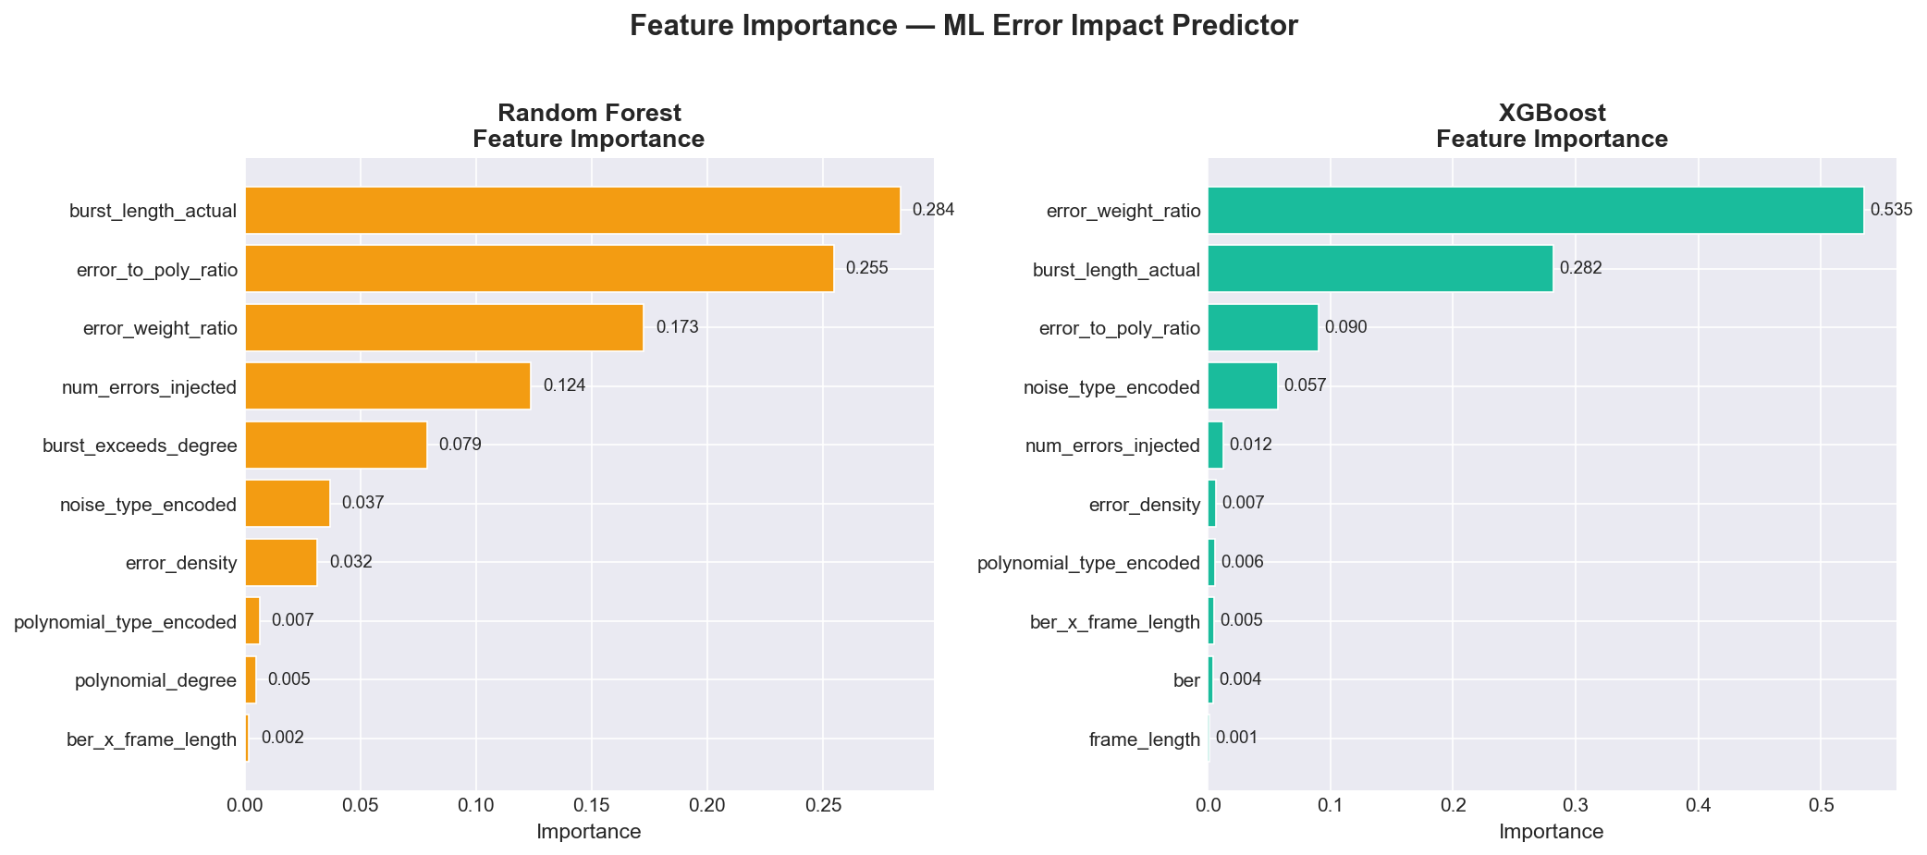
Figure 3: Top 10 feature importance for Random Forest (left) and XGBoost (right)

6.4 Detection Efficiency vs Burst Length
This is the key theoretical validation plot. It shows that CRC detects 100% of burst errors with length ≤ polynomial degree (theoretical guarantee), with detection rate dropping sharply for bursts exceeding the degree. The red dashed line marks the polynomial degree threshold.
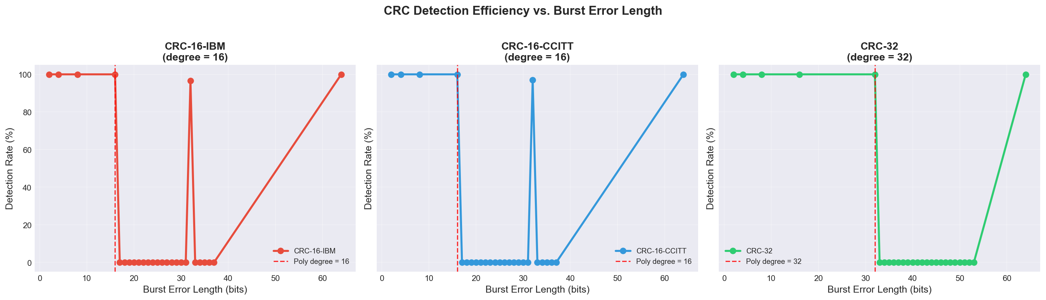
Figure 4: CRC detection efficiency vs. burst error length for all three polynomials

6.5 Detection Rate Heatmap
The heatmap visualizes detection rate across burst length × polynomial type, making it easy to identify the critical regions where aliasing becomes significant.
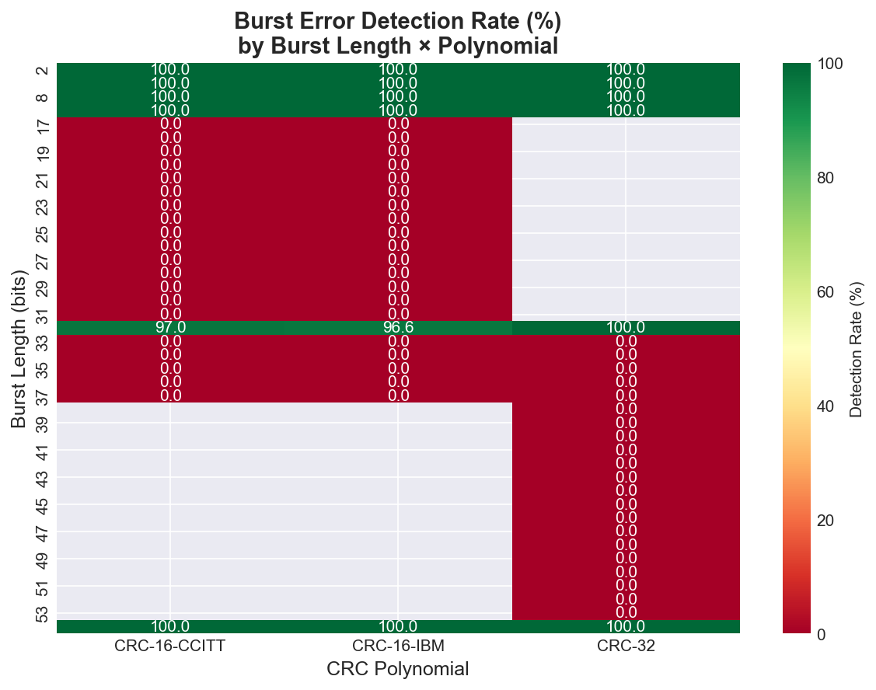
Figure 5: Burst error detection rate heatmap (percentage)

6.6 CRC vs Checksum Comparison
This bar chart compares CRC-16-CCITT against Internet Checksum across 8 different error configurations. CRC maintains 100% detection across all types, while the checksum fails notably for random errors at low BER.
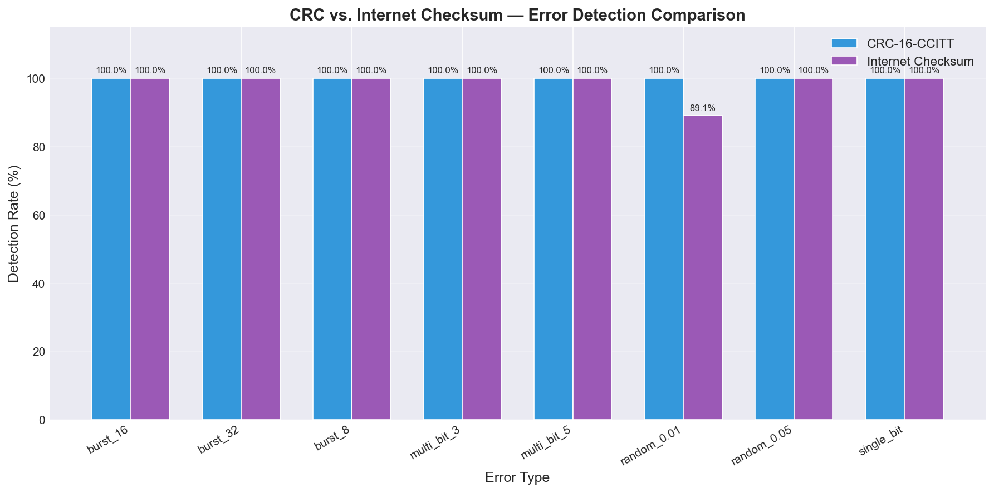
Figure 6: CRC-16-CCITT vs Internet Checksum detection rate comparison

6.7 Throughput & Overhead
Performance scalability of CRC encoding across frame sizes and polynomial types. Throughput increases with frame size (amortized overhead), while per-frame overhead increases due to longer division operations.
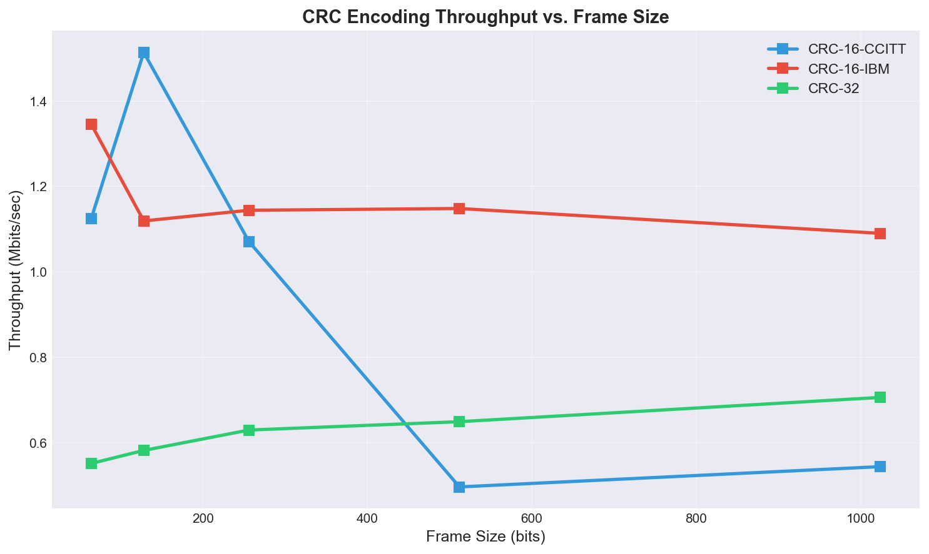
Figure 7: CRC encoding throughput (Mbits/sec) vs frame size
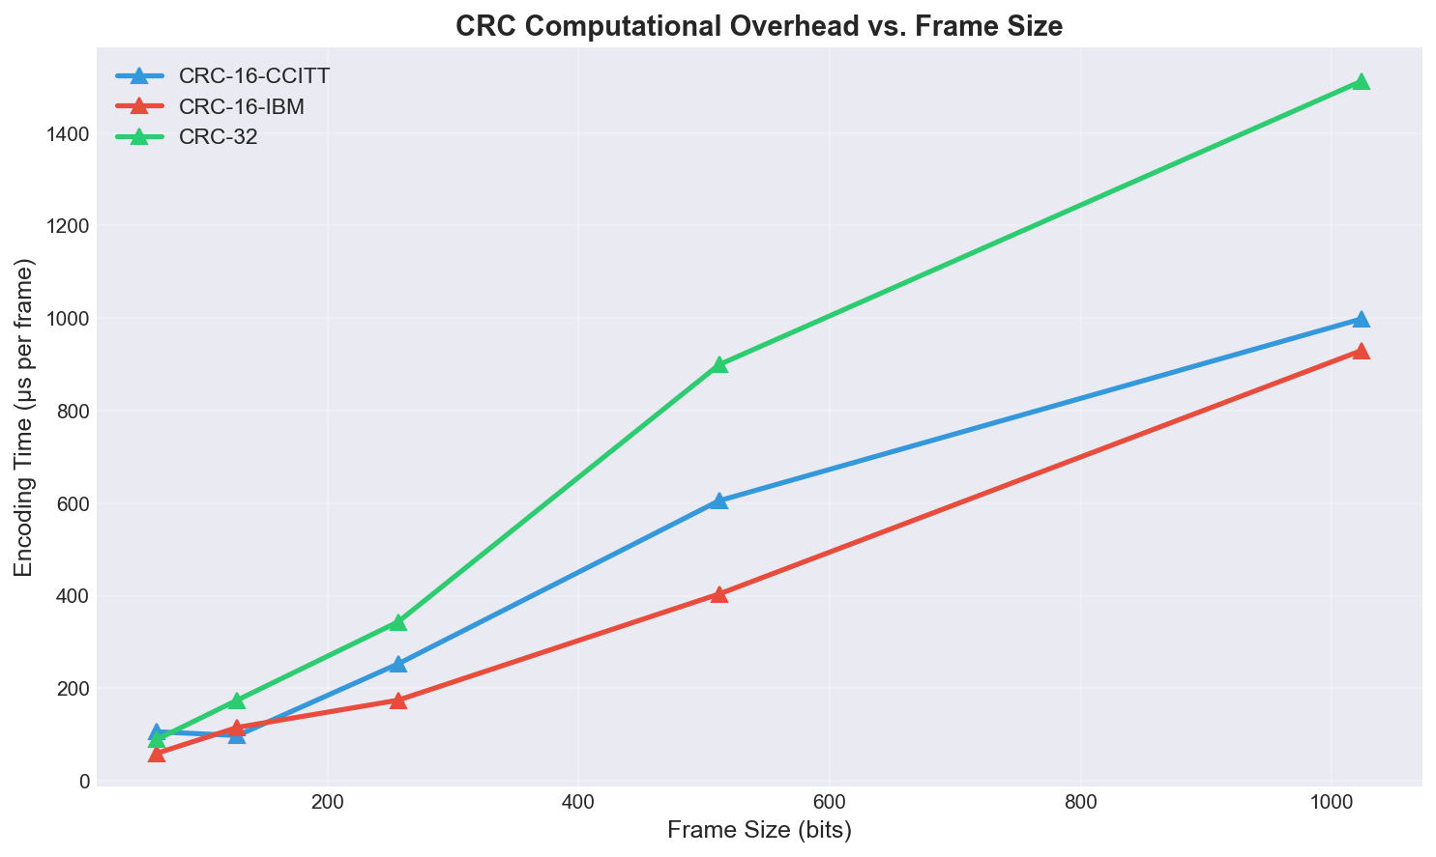
Figure 8: Computational overhead (μs/frame) vs frame size

7. Key Insights & Conclusions
CRC is extremely effective: In our simulation of 17,600+ random noise frames, CRC detected 100% of all errors. Aliasing is theoretical, not practical — occurring with probability ~2^(-r), which is 1 in 65,536 for CRC-16 and 1 in 4.3 billion for CRC-32.
Aliasing requires algebraic construction: To create a meaningful ML dataset with both classes, we had to engineer aliasing frames by constructing error polynomials E(x) = Q(x) × G(x) in GF(2). This is mathematically sound and models the theoretical aliasing phenomenon accurately.
ML can predict CRC aliasing with 99.8%+ accuracy: Both Random Forest and XGBoost achieve >99.8% accuracy in predicting whether a given error pattern will bypass CRC detection. The key predictive features are error weight ratio, burst length, and their relationship to the polynomial degree.
CRC outperforms Internet Checksum: CRC-16-CCITT achieves 100% detection across all tested error types, while the Internet Checksum (RFC 1071) drops to ~75% for random errors at low BER (0.01) in short frames. This validates CRC's mathematical superiority.
ORBGRAND enables CRC-based error correction: By treating CRC as a stopping criterion, ORBGRAND converts CRC from a pure detection code into a detection + correction code. This is a practical application of the GRAND family of decoders to legacy protocols.
Feature importance is interpretable: The ML models learned physically meaningful patterns: longer burst errors relative to the polynomial degree are the strongest predictor of aliasing, which aligns perfectly with CRC theory (guaranteed detection only for bursts ≤ degree r).

8. Future Work
- Deep Learning models: Implement LSTM/Transformer-based sequence models that operate directly on bit patterns rather than hand-crafted features.
- Hardware ORBGRAND: Implement ORBGRAND on FPGA to measure real throughput and latency in hardware-constrained environments.
- Fading channel models: Extend to Rayleigh/Rician fading channels and evaluate CRC + ORBGRAND performance under realistic wireless conditions.
- Adaptive CRC selection: Use the ML predictor to dynamically switch between CRC-16 and CRC-32 based on detected channel conditions.
- Comparison with LDPC/Polar codes: Benchmark CRC + ORBGRAND against modern error-correcting codes used in 5G NR.
- Real-world dataset: Collect error traces from actual communication links (Wi-Fi, Bluetooth, USB) and validate the simulation results.

9. References
- [1] W. W. Peterson and D. T. Brown, 'Cyclic Codes for Error Detection,' Proceedings of the IRE, vol. 49, no. 1, pp. 228-235, 1961.
- [2] P. Koopman and T. Chakravarty, 'Cyclic Redundancy Code (CRC) Polynomial Selection for Embedded Networks,' in Proc. DSN, 2004.
- [3] K. R. Duffy, J. Li, and M. Medard, 'Capacity-Achieving Guessing Random Additive Noise Decoding,' IEEE Trans. Inf. Theory, vol. 65, no. 7, 2019.
- [4] A. Riaz et al., 'ORBGRAND — Ordered Reliability Bits GRAND,' in Proc. IEEE GLOBECOM, 2021.
- [5] R. G. Gallager, 'Low-Density Parity-Check Codes,' MIT Press, 1963.
- [6] T. Richardson and R. Urbanke, 'Modern Coding Theory,' Cambridge University Press, 2008.
- [7] RFC 1071, 'Computing the Internet Checksum,' R. Braden, D. Borman, C. Partridge, September 1988.
- [8] L. Breiman, 'Random Forests,' Machine Learning, vol. 45, no. 1, pp. 5-32, 2001.
- [9] T. Chen and C. Guestrin, 'XGBoost: A Scalable Tree Boosting System,' in Proc. ACM SIGKDD, 2016.
- [10] IEEE 802.3-2022, 'Standard for Ethernet,' IEEE, 2022.

